1. Initial condition=0, i/p : Amplitude=1,Freq=1Hz

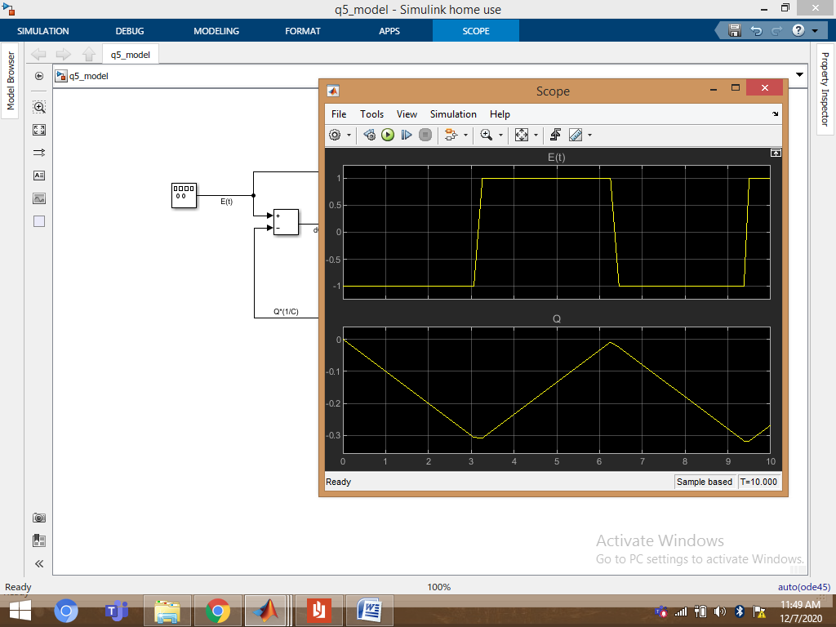

2. Initial condition=1, i/p : Amplitude=1,Freq=2Hz

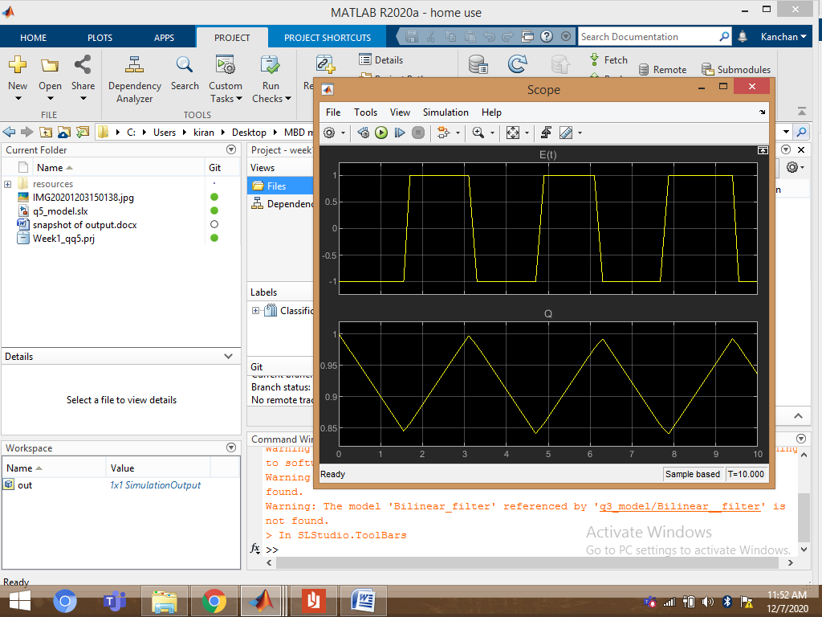

3. Initial condition=2, i/p : Amplitude=1,Freq=5Hz:

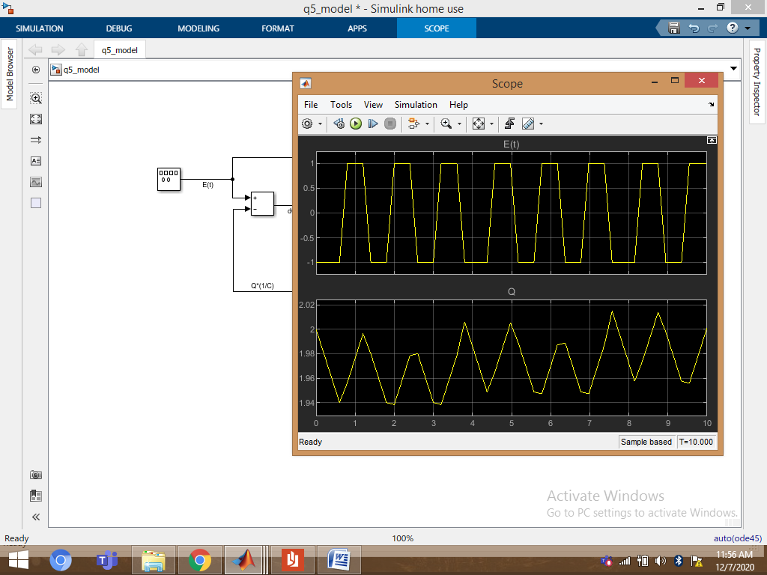

4. Initial condition=3, i/p : Amplitude=1,Freq=5Hz:

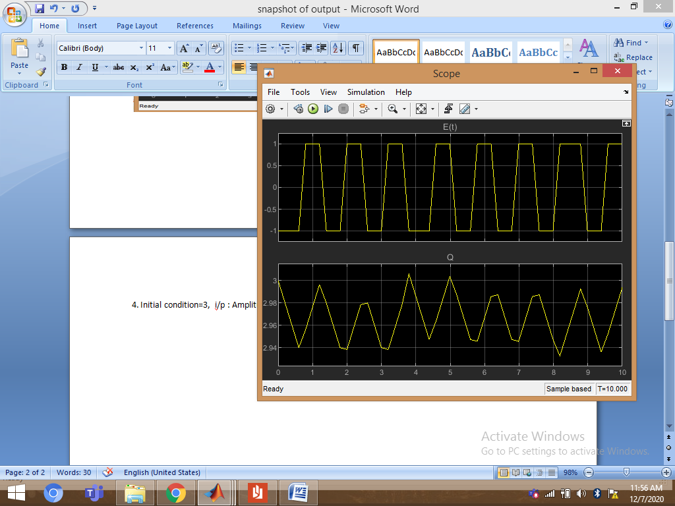

5. Initial condition=4, i/p : Amplitude=1,Freq=5Hz:

